***PAAREES PERFUMES***

***DAVID OFF***

***FOR WOMEN***

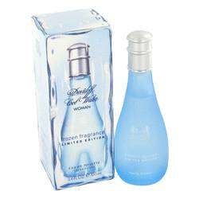

***Cool Water Frozen***

***Description:***

Cool Water Frozen by Davidoff Perfume. Enjoy the refreshing feeling of Cool Water Frozen for women. Created by the house of Davidoff in 2001, this lovely fragrance mixes intricate notes of pineapple, blackberry and orange with earthy amber and vetiver for an intoxicating blend that gets you noticed no matter where you go. Dabble some on as you head out the door for the office in the morning or right before meeting your significant other for a special romantic dinner date.